Product Overview
Payment Gateway solution aims to simplify and connect the entire payments world. Creating a dynamic, evolving solution and providing tools for pro-active collaboration amongst all parties. While disrupting and liberating us from today’s static and restrictive payments technology and business models

The system is designed to be fully automated and is completely transparent to a client.

The Payment gateway platform provides an online portal for merchants to search and report on their transactions as well as providing transaction handling capabilities to manage exceptions such as refunds and chargeback.

Functionalities
Channels of Payment
Hosted Payment Form
Shopping Cart Compatibility
Multiple Currency support
Credit Card Payments
Level II and Level III support
Refund & Void Capabilities
Tokenized transaction Management
Partial Refund and Settlement
Virtual Terminal
Merchant Account management
Reporting & Reconciliation
Global Verification of telephone and Address
Recurring Payments
Manage velocity and threshold.
Easy to configure and install
Audit log
Transaction Types
Authorization
Refund
Void
Settlement
Payment Methods
Visa
Master Card
Maestro
Diners
American Express
Generic APIs
System provides API for all Transaction types, and Pay page transaction that can be integrated with the merchant web site or merchant checkout

Value Added Features
Integrated fraud engine
Address Verification Service
3D Secure Authentication MPI
Negative List (Card number, Email, ip Address)
Role based security
Automated Alert Notification
Centralize database for managing and tracking global business
Multilingual support
Multi currency support
Designed for PCI compliance
AES 256 encryption for all sensitive data

Risk Management
System has inbuilt Fraud and Risk management module which is used to track fraudulent transactions. The system also provides to integrate with 3rd party Fraud and Risk management service.

System Architecture

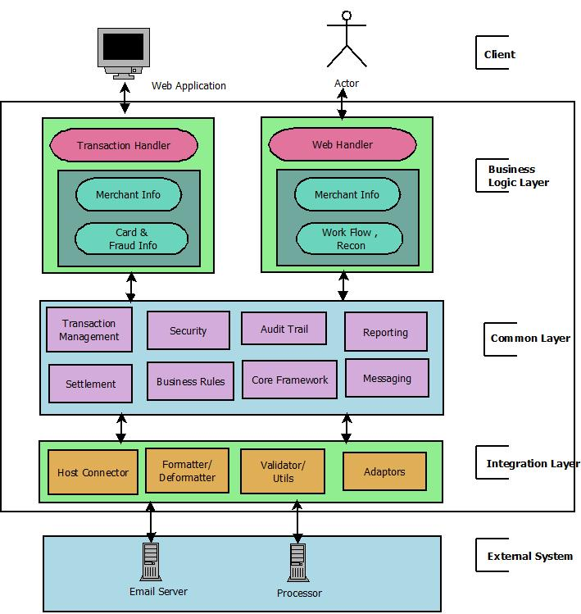

Architectural Highlights
Loosely coupled component based architecture
Each layer is separated for easy maintenance
Business rules are isolated in distinct business layer
Uses JQuery / AJAX for better user experience
Robust and scalable
Configurable Merchant processor and payment Methods

Security
Data Transmission Security
The platform uses 128 bit SSL (Secure Sockets Layer) to ensure the security of payment data transferred to our platform. All online requests submitted from Merchant system must be SSL encrypted and submitted to port 443.

All sensitive payment data is encrypted in the platform in line with PCI-DSS requirements. The system shall use Advance Encryption Standard (AES) 256, for encryption of sensitive data.
Technology Used
Operating System: Linux / Windows
Technology: JAVA EE, JSP, JSTL, Spring Framework, Spring Security, Quartz Scheduler
Database: PostgresSQL
Application / Web Server: Tomcat

